LEAF HEALTH CHECK SYSTEM

Team members:

Team leader : BENAZIR BANU.J
Team member 1: VARALAKSHMI.R
Team member 2: SHARMILA.S
Team member 3: SINDHUJA.J

1. INTRODUCTION

Agriculture plays a vital role in the economy and food production of many countries. Maintaining plant health is essential for ensuring high crop productivity and sustainable farming practices. Plant diseases can significantly affect crop yield and quality if they are not detected at an early stage. Traditionally, farmers and gardeners identify plant diseases through manual inspection, which requires experience and expert knowledge.
However, early symptoms of plant diseases such as yellowing, browning, and spots on leaves are sometimes difficult to detect. Delayed detection can lead to severe plant damage and reduced agricultural productivity. Therefore, there is a growing need for intelligent systems that can automatically analyze plant health and provide quick diagnosis.
With the advancement of Artificial Intelligence (AI) and Computer Vision, it has become possible to develop automated systems that can analyze plant images and detect diseases accurately. AI-based systems can process large amounts of visual data and identify patterns that indicate plant health conditions.
The Leaf Health Check System is designed to provide a smart solution for plant health monitoring. The system allows users to upload an image of a plant leaf through an interactive web interface built using the Streamlit framework. The uploaded image is analyzed using image processing techniques and AI models to detect discoloration patterns and possible diseases.
The application identifies the plant species, predicts possible diseases, determines the severity level of leaf damage, and provides helpful rescue recommendations. These recommendations guide users in taking corrective actions to improve plant health and prevent further damage.
The system aims to assist farmers, gardeners, students, and agricultural researchers in detecting plant diseases quickly and easily without requiring expert knowledge. By integrating artificial intelligence with a simple web-based interface, the project promotes smart agriculture and efficient plant health management.

2. PROJECT DESCRIPTION

2.1 System Overview
The Leaf Health Check System is an AI-powered plant disease detection application designed to analyze plant leaf images and determine plant health conditions. The system allows users to upload images of plant leaves through a simple web interface built using the Streamlit framework. Once the image is uploaded, the system processes it using advanced image processing and artificial intelligence techniques to detect possible plant diseases.
The system examines the leaf image to identify visual symptoms such as discoloration, yellow spots, brown patches, or texture damage. Based on this analysis, the application predicts whether the plant leaf is healthy or affected by a disease.

2.2 Problem Domain
Plant diseases are one of the major factors affecting crop productivity and plant growth. Farmers and gardeners often rely on manual inspection to identify plant diseases, which requires expert knowledge and time. In many cases, early symptoms of diseases are ignored or misidentified, resulting in severe plant damage.
An automated system that can analyze plant leaf images and detect diseases quickly can greatly help farmers and plant enthusiasts. Such a system reduces the dependency on experts and enables early detection of plant health problems.

2.3 Key Capabilities of the System
The Leaf Health Check System provides several important features:
Upload plant leaf images for analysis
Detect discoloration patterns such as yellowing or browning
Identify plant species from the uploaded image
Predict possible plant diseases using AI models
Calculate the severity level of leaf damage
Provide rescue recommendations for plant recovery
Generate a clear diagnosis report for the user

2.4 Target Users
The system is designed for the following users:
Farmers who want to detect crop diseases early
Gardeners who want to maintain healthy plants
Students studying agriculture or plant science
Researchers analyzing plant diseases
Home gardening enthusiasts
The Leaf Health Check System simplifies plant health monitoring and provides a quick and intelligent solution for disease detection.

3. APPLICATION SCENARIOS / USE CASES

The Leaf Health Check System can be used in various real-world situations to monitor plant health and detect diseases at an early stage. The following scenarios explain how different users can benefit from the system.

3.1 Farmer Disease Detection
Farmers can use the system to quickly detect diseases in crop plants. By uploading an image of a plant leaf, the system analyzes the leaf condition and predicts possible diseases. The system also provides severity levels and rescue tips, helping farmers take immediate corrective actions to prevent crop loss.

3.2 Home Gardening Assistance
Home gardeners often face difficulty identifying plant health issues. Using the Leaf Health Check application, gardeners can upload leaf images from their plants and receive an instant diagnosis. The system provides useful recommendations such as improving watering schedules, applying fertilizers, or adjusting sunlight exposure.

3.3 Agricultural Research Support
Researchers studying plant diseases can use the system as a supportive tool for analyzing plant leaf images. The application can assist in identifying disease patterns and understanding plant health conditions based on visual symptoms.

3.4 Educational Learning Tool
The system can also be used by students learning about plant diseases and agricultural technologies. It provides a practical demonstration of how Artificial Intelligence and Computer Vision can be applied in agriculture.

3.5 Plant Health Monitoring
The application helps users continuously monitor plant health by analyzing leaf images at different stages of plant growth. Early detection of diseases enables timely treatment and improves plant survival rates.
The Leaf Health Check System provides a simple and efficient way to detect plant diseases and maintain healthy plants.

4. SYSTEM ARCHITECTURE

System architecture defines the overall structure of the Leaf Health Check System and explains how different components interact to perform plant disease detection and health analysis.
The Leaf Health Check System follows a modular architecture consisting of several components such as the user interface, image processing module, AI prediction model, severity grading engine, and recommendation system. Each component works together to analyze plant leaf images and generate accurate diagnosis results.

4.1 User Interface Layer
The user interface is developed using the Streamlit framework, which provides an interactive web-based environment for users. Through this interface, users can upload plant leaf images, initiate analysis, and view the diagnosis results. The interface also displays plant species information, disease predictions, severity levels, and rescue recommendations.

4.2 Image Processing Module
The image processing module is responsible for preparing the uploaded leaf image for analysis. It performs several operations including image resizing, normalization, color conversion, and noise reduction. These preprocessing steps improve the accuracy of the AI model by ensuring that the image data is clean and standardized.

4.3 AI Model Layer
The AI model layer uses deep learning techniques to analyze the processed leaf image. The model identifies the plant species and predicts possible diseases by analyzing visual patterns such as discoloration, spots, or texture changes. The model also generates a confidence score indicating the reliability of the prediction.

4.4 Severity Grading Engine
The severity grading engine evaluates the level of damage present in the leaf. It calculates the percentage of discoloration or affected regions and classifies the leaf condition into categories such as Healthy, Mild, Moderate, Severe, or Dying.

4.5 Recommendation Engine
Based on the detected disease and severity level, the recommendation engine generates helpful rescue tips. These tips guide users in taking corrective actions such as adjusting watering schedules, applying fertilizers, improving sunlight exposure, or using suitable treatments.

4.6 Output Display
The final results are displayed to the user in a structured format that includes the plant name, predicted disease, severity level, confidence score, and rescue recommendations. Users can also download the diagnosis report for future reference.

5. TECHNOLOGY STACK

The Leaf Health Check System uses several modern technologies and software tools to develop an intelligent plant disease detection application. These technologies help in building the user interface, processing images, running artificial intelligence models, and managing data efficiently.

5.1 Programming Language
Python
Python is the primary programming language used for developing this project. It is widely used in artificial intelligence, machine learning, and data processing due to its simplicity and powerful libraries. Python provides strong support for image processing, AI model development, and web application frameworks.

5.2 Web Application Framework
Streamlit
Streamlit is used to build the web-based user interface of the application. It allows developers to quickly create interactive data applications using Python. In this project, Streamlit enables users to upload plant leaf images, view analysis results, and download reports easily.

5.3 Artificial Intelligence Framework
TensorFlow / PyTorch
Deep learning frameworks such as TensorFlow or PyTorch are used for building and running the AI model that predicts plant diseases. These frameworks allow the system to analyze complex image patterns and classify plant health conditions accurately.

5.4 Image Processing Library
OpenCV
OpenCV is used for processing the uploaded leaf images. It performs tasks such as image resizing, noise removal, color detection, and discoloration analysis. These preprocessing steps improve the accuracy of the AI prediction model.

5.5 Data Processing Libraries
NumPy and Pandas
NumPy and Pandas are used for handling numerical data and performing data analysis operations within the application. These libraries support efficient data manipulation and processing.

5.6 Database System
SQLite / PostgreSQL
A database system is used to store plant species information, common diseases, and treatment recommendations. This database helps the system provide accurate diagnosis and rescue suggestions.

5.7 Visualization Tools
Matplotlib / PIL
These libraries are used for displaying images and visualizing results within the application interface.
The combination of these technologies enables the development of a powerful and user-friendly AI-based plant disease detection system.

6. SYSTEM WORKFLOW

The Leaf Health Check System follows a structured workflow to analyze plant leaf images and generate accurate diagnosis results. The workflow explains how the system processes the user input and produces the final output.
The system begins with the user uploading an image of a plant leaf through the Streamlit interface. Once the image is uploaded, the system performs several processing steps to analyze the leaf condition and identify possible diseases.

Step 1: Image Upload
The user uploads a plant leaf image using the file upload option provided in the Streamlit web interface. The system accepts image formats such as JPG, PNG, or JPEG.

Step 2: Image Preprocessing
After uploading, the image is processed using image processing techniques. This step includes resizing the image, converting it to the required color format, normalizing pixel values, and removing noise. These operations help improve the accuracy of the analysis.

Step 3: Discoloration Detection
The system analyzes the leaf image to detect discoloration patterns such as yellowing, browning, or dark spots. These visual symptoms are important indicators of plant diseases or nutrient deficiencies.

Step 4: AI-Based Disease Prediction
The processed image is then passed to the artificial intelligence model. The AI model examines the leaf patterns and predicts the plant species and possible disease affecting the plant. The system also generates a confidence score for the prediction.

Step 5: Severity Level Calculation
The system calculates the percentage of damaged or discolored regions in the leaf. Based on this percentage, the severity grading engine classifies the leaf condition into one of the following categories:
Healthy
Mild
Moderate
Severe
Dying

Step 6: Rescue Recommendation Generation
Based on the disease prediction and severity level, the system generates three personalized rescue tips. These suggestions help users take appropriate actions to improve plant health.

Step 7: Result Display
Finally, the system displays the diagnosis results to the user. The output includes the plant name, predicted disease, confidence score, severity level, and rescue recommendations. The user can also download the diagnosis report for future reference.

7. IMPLEMENTATION

The implementation phase involves developing the Leaf Health Check System by integrating artificial intelligence, image processing techniques, and a user-friendly web interface. The system is developed using Python and the Streamlit framework, which allows the creation of interactive web applications for data analysis and visualization.

7.1 Application Development
The application is developed as a web-based system where users can upload plant leaf images for analysis. The main application file, app.py, controls the entire workflow of the system. It manages user input, image processing, AI prediction, and result display.
The system is designed with modular components to ensure better organization and maintainability. Each module performs a specific function such as image preprocessing, disease prediction, severity analysis, and recommendation generation.

7.2 Image Processing Implementation
Image processing plays a crucial role in analyzing the plant leaf images. The uploaded images are processed using the OpenCV library. The system performs operations such as image resizing, color conversion, and noise reduction to prepare the image for accurate analysis.
The system also detects discoloration patterns such as yellow or brown regions on the leaf. These patterns help in identifying possible diseases or nutrient deficiencies.

7.3 AI Model Integration
The system integrates a deep learning model to analyze leaf images and predict plant diseases. The AI model is trained using plant leaf datasets containing images of healthy and diseased leaves. The trained model is stored in the project directory and loaded during application startup.
When a user uploads an image, the system passes the processed image to the AI model, which then predicts the plant species and disease class along with a confidence score.

7.4 Severity Grading Implementation
The severity grading engine calculates the percentage of affected areas in the leaf image. Based on this value, the system classifies the leaf health into categories such as Healthy, Mild, Moderate, Severe, or Dying.

7.5 Recommendation Generation
After determining the disease type and severity level, the system generates rescue recommendations. These suggestions guide users in taking appropriate actions such as improving watering practices, applying fertilizers, or providing better sunlight conditions for the plant.
The implementation ensures that the system provides accurate analysis results while maintaining a simple and easy-to-use interface for users.

8. USER INTERFACE DESIGN

The Leaf Health Check System is designed with a simple and user-friendly interface to ensure that users can easily interact with the application. The user interface is developed using the Streamlit framework, which allows the creation of interactive web applications using Python.
The interface focuses on simplicity, clarity, and ease of use so that farmers, students, and gardening enthusiasts can operate the system without requiring technical knowledge.

8.1 Home Page Interface
The home page serves as the main entry point of the application. It displays the application title and a short description explaining the purpose of the system. The page also provides instructions for users on how to upload plant leaf images for analysis.

The home page includes the following components:
Application title and description
Image upload section
Information about supported image formats
Analyze button to start leaf analysis

8.2 Image Upload Interface
The image upload section allows users to select and upload plant leaf images from their device. The system accepts common image formats such as JPG, PNG, and JPEG.
Once an image is uploaded, the application displays a preview of the leaf image so the user can confirm the selected file before starting the analysis.

8.3 Analysis Result Display
After the image analysis is completed, the system displays the diagnosis results on the interface. The output section presents important information including:
Detected plant species
Predicted disease name
Confidence score of the prediction
Severity level of leaf damage
The severity level is visually highlighted to help users quickly understand the plant’s health condition.

8.4 Rescue Recommendation Section
The interface also displays three rescue recommendations that guide users in improving plant health. These tips are presented in a clear and easy-to-read format so that users can immediately take corrective actions.

8.5 Report Download Option
The system provides an option for users to download the diagnosis report. This feature allows users to save the results for future reference or share them with agricultural experts.
The overall interface design ensures a smooth and intuitive experience for users while performing plant disease analysis.

9. PROJECT STRUCTURE

The Leaf Health Check System follows a well-organized project structure to maintain code readability, modularity, and efficient development. The project is divided into different folders and files, each responsible for a specific function within the system.

9.1 Folder Structure

Copy code

Leaf-Health-Check/
│
├── app.py
├── requirements.txt
├── README.md
│
├── model/
│ └── plant_disease_model.h5
│
├── database/
│ └── plant_database.db
│
├── src/
│ ├── image_processing.py
│ ├── severity_engine.py
│ └── recommendation_engine.py
│
├── static/
│ └── sample_images/
│
└── reports/
└── diagnosis_reports/

9.2 File and Folder Explanation
app.py
This is the main application file that runs the Streamlit interface. It controls the workflow of the system including image upload, analysis, and result display.
requirements.txt
This file contains the list of required Python libraries used in the project such as Streamlit, OpenCV, TensorFlow, NumPy, and Pandas.
model/
This folder stores the trained AI model used for plant disease detection and prediction.
database/
The database folder contains plant species information and disease-related data used for diagnosis and recommendations.
src/
This folder contains the core modules responsible for system functionality such as image processing, severity grading, and rescue recommendation generation.
static/
This folder stores static resources such as sample images used for testing the system.
reports/
The reports folder stores generated diagnosis reports that users can download after analysis.
This organized structure helps in maintaining the project effectively and simplifies future development and updates.

10. RESULTS

The Leaf Health Check System was successfully developed and tested to analyze plant leaf images and detect possible diseases. The system demonstrates the ability to process uploaded leaf images, identify plant health conditions, and generate accurate diagnosis reports.
10.1 System Output
When a user uploads a plant leaf image through the Streamlit interface, the system processes the image and performs AI-based analysis. The output generated by the system includes the following information:
Plant species identification
Predicted plant disease
Confidence score of the prediction
Severity level of leaf damage
Rescue recommendations for plant recovery
The results are displayed clearly on the application interface, making it easy for users to understand the plant health condition.

10.2 Performance Evaluation
The system was tested using multiple leaf images with different health conditions, including healthy leaves, leaves with yellow discoloration, brown spots, and severely damaged leaves.
The evaluation results show that the system is capable of detecting plant diseases effectively and providing useful recommendations. The image processing module accurately detects discoloration patterns, while the AI model predicts possible diseases based on visual features.

10.3 Output Screens
The following application screens demonstrate the functionality of the system:

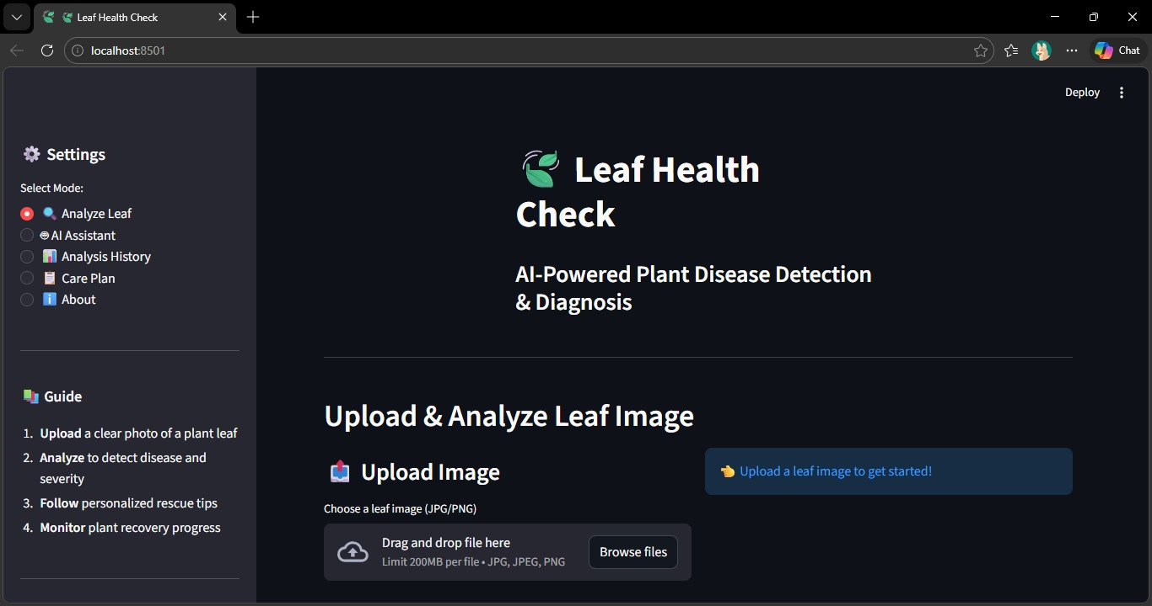

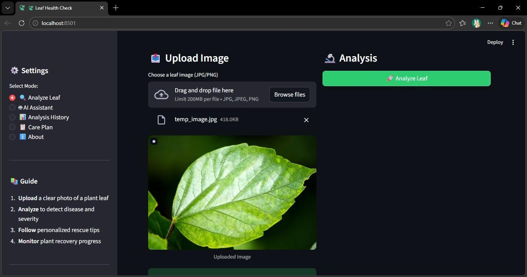
Image upload interface
Leaf image preview
AI-based diagnosis result
Severity grading display
Rescue recommendation section

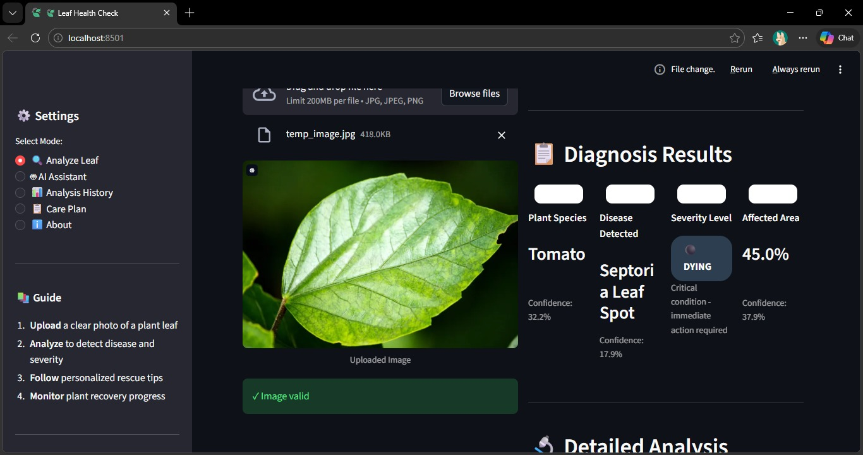

The system detects Tomato Leaf Spot and reports the severity level as dying with about 45% affected area.

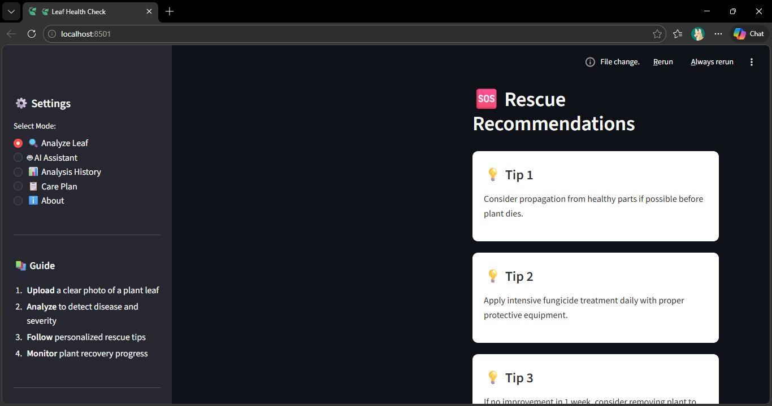

Report download option
These outputs confirm that the system works as intended and provides useful information for plant health monitoring.

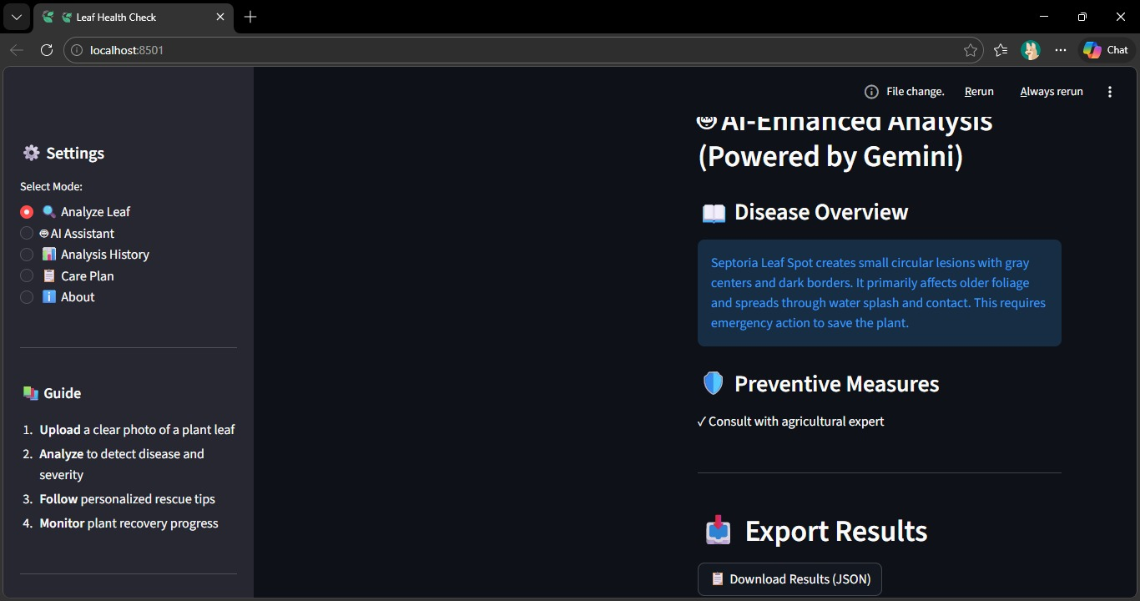

It provides a disease overview of Leaf Spot and suggests preventive measures along with an option to export the results.

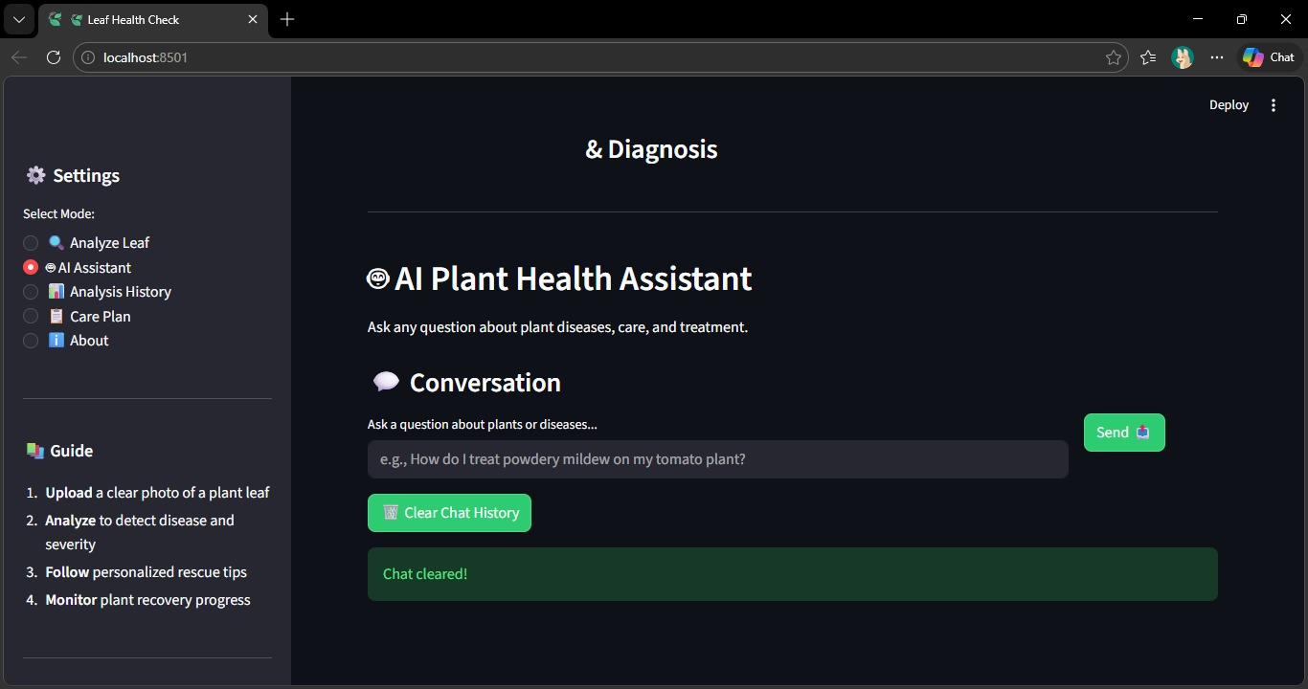

This image shows the AI Plant Health Assistant feature in the Leaf Health Check application,It allows users to ask questions about plant diseases, care, and treatment through an interactive AI conversation interface.

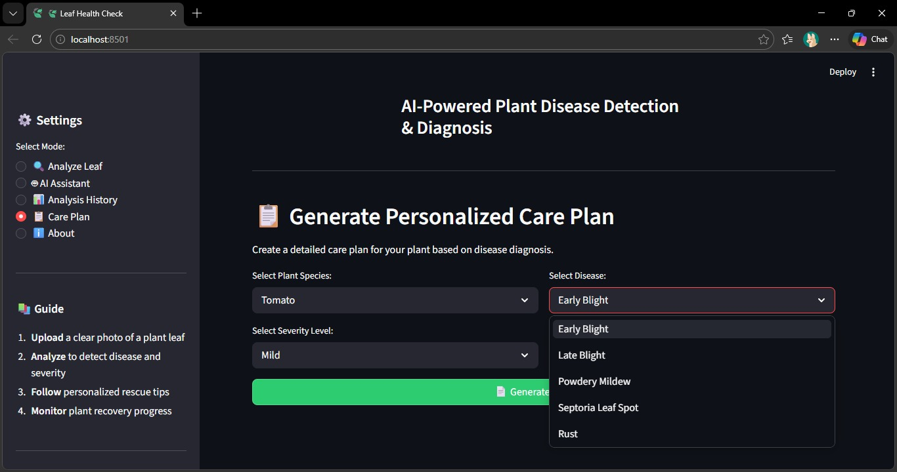

This image shows the Generate Personalized Care Plan feature in the AI-Powered Plant Disease Detection system.

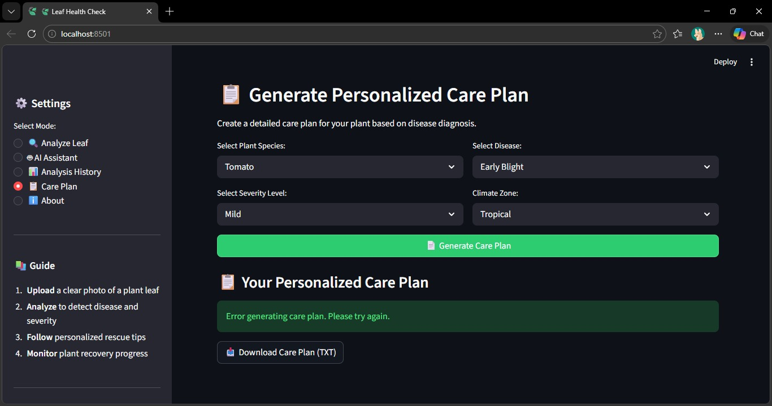

Users can select the plant species, disease type, and severity level to generate a customized treatment and care plan for the plant

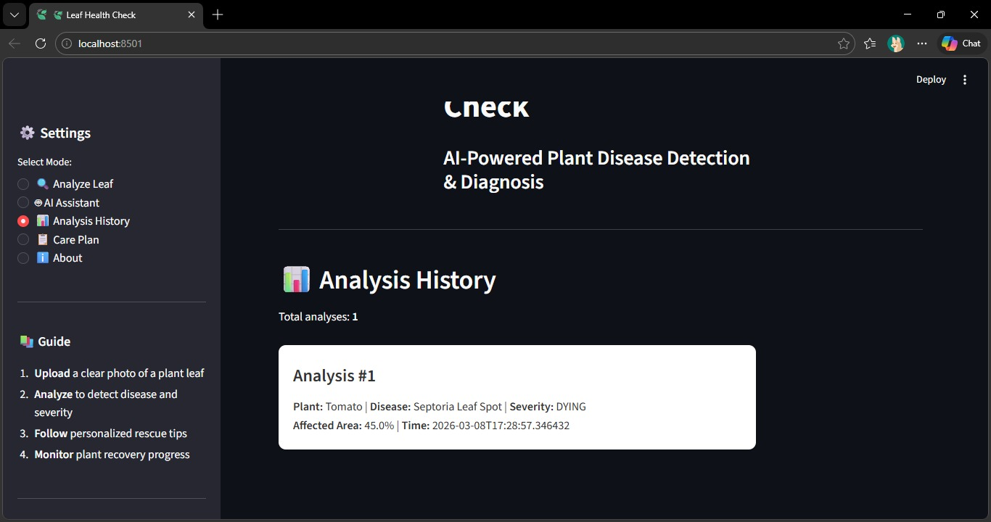

11. ADVANTAGES AND LIMITATIONS

The Leaf Health Check System provides several benefits for plant health monitoring, but it also has certain limitations that should be considered.

11.1 Advantages
The following are the major advantages of the Leaf Health Check System:

1. Early Disease Detection
The system helps detect plant diseases at an early stage by analyzing leaf images. Early detection allows users to take corrective actions before the disease spreads.

2. Easy to Use
The application provides a simple and user-friendly interface that allows users to upload leaf images and receive analysis results quickly.

3. Time Saving
The automated analysis reduces the time required for manual inspection and provides instant diagnosis results.

4. Supports Smart Agriculture
The system uses artificial intelligence and image processing technologies, promoting the use of modern technology in agriculture.

5. Helpful for Multiple Users
Farmers, gardeners, students, and agricultural researchers can use the system to monitor plant health and detect diseases.

11.2 Limitations
Despite its advantages, the system has certain limitations:

1. Dependence on Image Quality
The accuracy of the system depends on the quality of the uploaded leaf image. Low-quality or blurred images may reduce prediction accuracy.

2. Limited Plant Database
The system may support only a limited number of plant species and diseases depending on the dataset used for training the AI model.

3. Internet Dependency
If the system uses cloud-based AI services, an internet connection may be required for performing the analysis.

4. Rare Disease Detection
The system may not detect extremely rare plant diseases that are not included in the training dataset.
Understanding these limitations helps in improving the system and planning future enhancements.

12. FUTURE ENHANCEMENTS

The Leaf Health Check System provides an effective solution for detecting plant diseases using artificial intelligence and image processing techniques. However, the system can be further improved by implementing additional features and advanced technologies in the future.

12.1 Support for More Plant Species
Currently, the system may support a limited number of plant species depending on the available dataset. In the future, the database can be expanded to include a larger variety of plants and diseases to improve the system’s usability and accuracy.

12.2 Mobile Application Development
The application can be converted into a mobile application for Android and iOS platforms. This will allow farmers and gardeners to easily capture leaf images using their mobile phones and receive instant diagnosis results.

12.3 Real-Time Camera Integration
Future versions of the system can include real-time camera support. Users will be able to scan plant leaves directly using a camera without manually uploading images.

12.4 Cloud-Based Deployment
The system can be deployed on cloud platforms such as AWS, Azure, or Google Cloud. Cloud deployment will allow multiple users to access the application simultaneously from different locations.

12.5 Integration with IoT Devices
The system can be integrated with Internet of Things (IoT) sensors to monitor environmental conditions such as temperature, humidity, and soil moisture. This will provide a more comprehensive plant health monitoring system.

12.6 Improved AI Models
More advanced deep learning models can be implemented to increase the accuracy of plant disease detection and reduce prediction errors.
These enhancements will make the Leaf Health Check System more powerful, scalable, and useful for modern agricultural practices.

13. CONCLUSION

The Leaf Health Check System successfully demonstrates the use of artificial intelligence and image processing techniques for plant disease detection and plant health monitoring. The system allows users to upload plant leaf images and receive instant analysis results, including plant species identification, disease prediction, severity grading, and rescue recommendations.
The application is developed using the Streamlit framework, which provides a simple and interactive interface for users. By integrating image processing tools such as OpenCV and AI models for disease prediction, the system can analyze leaf images efficiently and provide meaningful insights about plant health.
The system helps farmers, gardeners, and agricultural enthusiasts detect plant diseases at an early stage. Early detection enables users to take corrective actions, reduce plant damage, and improve crop productivity. The rescue recommendations provided by the system guide users in maintaining better plant care practices.
The project highlights the importance of applying modern technologies such as Artificial Intelligence, Computer Vision, and Web Applications in agriculture. It shows how technology can simplify complex tasks like plant disease diagnosis and make them accessible to a wider audience.
Overall, the Leaf Health Check System provides a practical and intelligent solution for plant health monitoring and contributes to the advancement of smart agriculture and sustainable farming practices.

